**Pre- Application for Homeownership**

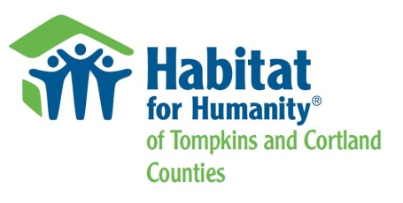

Name of applicant(s): Date:

Mailing address: ` Phone #:

Email:

**Maximum Gross Household** Income Guidelines for applicants living in Tompkins County for 2017:

|  |  |  |  |  |  |  |  |
| --- | --- | --- | --- | --- | --- | --- | --- |
| **1 person** | **2 person** | **3 person** | **4 person** | **5 person** | **6 person** | **7 person** | **8 person** |
| **$31,800** | **$36,300** | **$40,860** | **$45,360** | **$49,020** | **$52,620** | **$56,280** | **$59,880** |

**Maximum Gross Household** Income Guidelines for applicants living in Cortland County for 2017:

|  |  |  |  |  |  |  |  |
| --- | --- | --- | --- | --- | --- | --- | --- |
| **1 person** | **2 person** | **3 person** | **4 person** | **5 person** | **6 person** | **7 person** | **8 person** |
| **$27,300** | **$31,200** | **$35,100** | **$38,940** | **$42,060** | **$45,180** | **$48,300** | **$51,420** |

1. Estimated Annual Gross Income for Household $ ______________
2. What are the sources of income? (i.e. wages, Social Security income, Section 8, child support, or any other sources of household income)
3. Have you been living, working, or had a child in a school district in Cortland or Tompkins County for at least 1 year?
4. Have you been living in New York State for at least 2 years?
5. Have you owned a home in the last three years?
6. How many people in your family would be living in the house?
7. What are the household members’ ages and genders?
8. Marital status? __ Married __ Un-married (Note: un-married includes single, divorced and widowed)
9. How did you hear about Habitat for Humanity of Tompkins & Cortland Counties?

PLEASE RETURN: mail to PO Box 4683 Ithaca, NY 14852 OR email to [info@tchabitat.com](mailto:info@tchabitat.com)



*Through shelter, we empower.*